**NAME : SREE SANTHIKRISHNA S**

**REG NO : 727721EUCS149**

**CC – 1**

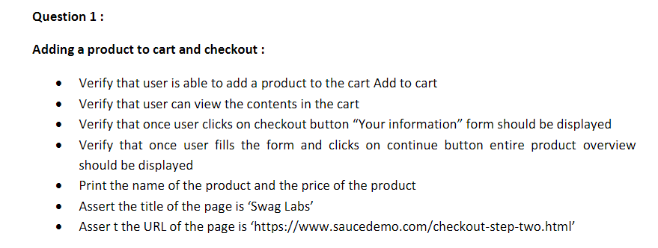

package cc1;

import org.openqa.selenium.By;

import org.openqa.selenium.WebDriver;

import org.openqa.selenium.chrome.ChromeDriver;

import org.openqa.selenium.chrome.ChromeOptions;

import io.github.bonigarcia.wdm.WebDriverManager;

public class question1 {

public static void main(String[] args) throws InterruptedException {

// TODO Auto-generated method stub

ChromeOptions co = new ChromeOptions();

co.addArguments("--remote-allow-orginis=*");

WebDriverManager.chromedriver().setup();

WebDriver driver = new ChromeDriver();

driver.get("https://www.saucedemo.com/");

driver.manage().window().maximize();

driver.findElement(By.xpath("/html/body/div/div/div[2]/div[1]/div/div/form/div[1]/input")).sendKeys("standard_user");

driver.findElement(By.xpath("/html/body/div/div/div[2]/div[1]/div/div/form/div[2]/input")).sendKeys("secret_sauce");

driver.findElement(By.xpath("/html/body/div/div/div[2]/div[1]/div/div/form/input")).click();

// Thread.sleep(3000);

driver.findElement(By.xpath("/html/body/div/div/div/div[2]/div/div/div/div[1]/div[2]/div[2]/button")).click();

String str1=driver.findElement(By.xpath("/html/body/div/div/div/div[2]/div/div/div/div[1]/div[2]/div[2]/button")).getText();

if(str1.equals("Remove")) {

System.out.println("Item added to cart");

}

else {

System.out.println("Item not added");

}

driver.findElement(By.xpath("/html/body/div/div/div/div[1]/div[1]/div[3]/a")).click();

String str2=driver.findElement(By.xpath("/html/body/div/div/div/div[1]/div[2]/span")).getText();

if(str2.equals("Your Cart")) {

System.out.println("User can view contents in the cart");

}

else {

System.out.println("User cannot view contents in the cart");

}

driver.findElement(By.xpath("//*[@id=\"checkout\"]")).click();

String str3=driver.findElement(By.xpath("/html/body/div/div/div/div[1]/div[2]/span")).getText();

if(str3.equals("Checkout: Your Information")) {

System.out.println("Your Information form is displayed");

}

else {

System.out.println("Your Information form is not displayed");

}

driver.findElement(By.xpath("//*[@id=\"first-name\"]")).sendKeys("Sree");

driver.findElement(By.xpath("//*[@id=\"last-name\"]")).sendKeys("V");

driver.findElement(By.xpath("//*[@id=\"postal-code\"]")).sendKeys("123456");

driver.findElement(By.xpath("//*[@id=\"continue\"]")).click();

String str4=driver.findElement(By.xpath("/html/body/div/div/div/div[1]/div[2]/span")).getText();

if(str4.equals("Checkout: Overview")) {

System.out.println("Product overview is displayed");

}

else {

System.out.println("Product overview is not displayed");

}

System.out.println("Name of the product: " + driver.findElement(By.xpath("/html/body/div/div/div/div[2]/div/div[1]/div[3]/div[2]/a/div")).getText());

System.out.println("Price of the product: " + driver.findElement(By.xpath("/html/body/div/div/div/div[2]/div/div[1]/div[3]/div[2]/div[2]/div")).getText());

String actualURL=driver.getCurrentUrl();

String expectedURL="https://www.saucedemo.com/checkout-step-two.html";

if(expectedURL.equals(actualURL)) {

System.out.println("URL MATCHED");

}

else {

System.out.println("URL DID NOT MATCH");

}

String actualTitle=driver.getTitle();

String expectedTitle="Swag Labs";

if(expectedTitle.equals(actualTitle)) {

System.out.println("Title MATCHED");

}

else {

System.out.println("Title DID NOT MATCH");

}

driver.close();

}

}

**OUTPUT :**

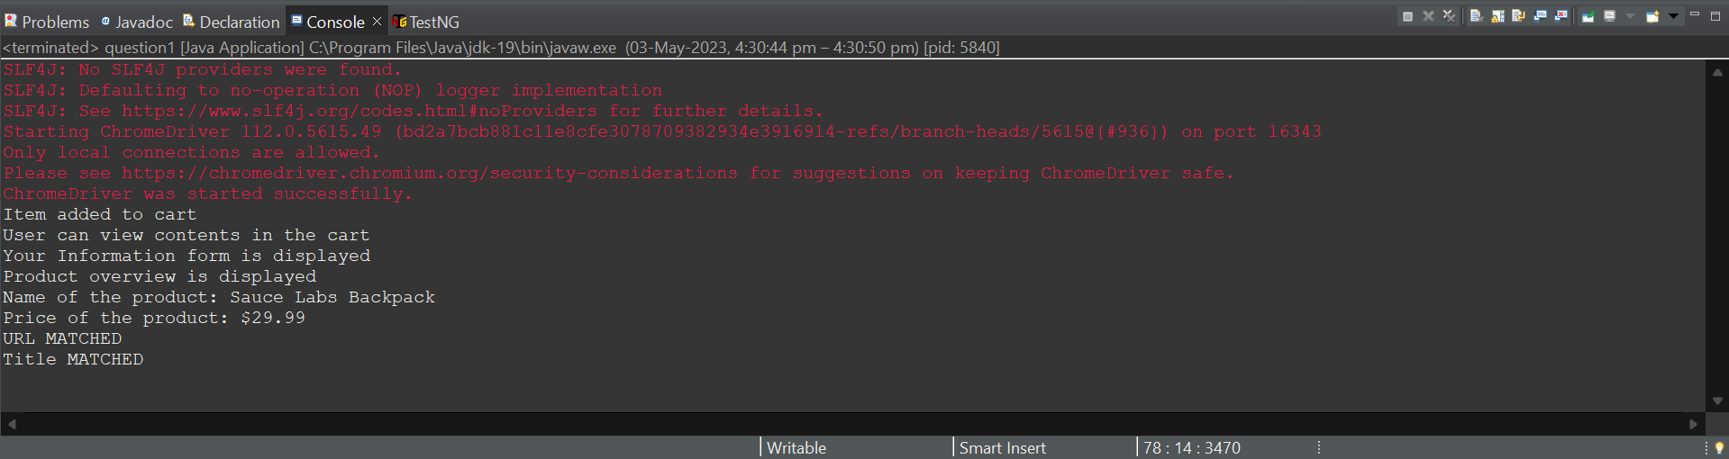

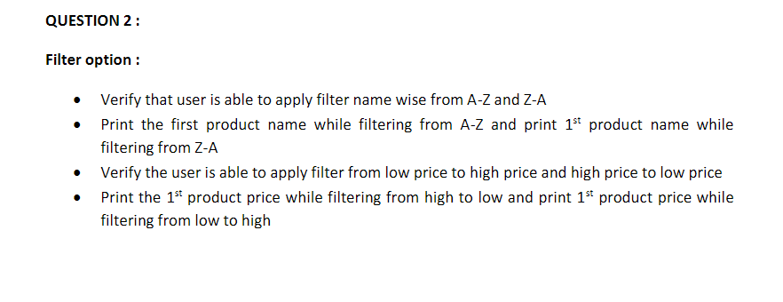

**CODE :**

package cc1;

import org.openqa.selenium.By;

import org.openqa.selenium.WebDriver;

import org.openqa.selenium.chrome.ChromeDriver;

import org.openqa.selenium.chrome.ChromeOptions;

import org.openqa.selenium.support.ui.Select;

import io.github.bonigarcia.wdm.WebDriverManager;

public class question2 {

public static void main(String[] args) throws InterruptedException {

// TODO Auto-generated method stub

ChromeOptions co = new ChromeOptions();

co.addArguments("--remote-allow-orginis=*");

WebDriverManager.chromedriver().setup();

WebDriver driver = new ChromeDriver();

driver.get("https://www.saucedemo.com/");

driver.manage().window().maximize();

driver.findElement(By.xpath("/html/body/div/div/div[2]/div[1]/div/div/form/div[1]/input")).sendKeys("standard_user");

driver.findElement(By.xpath("/html/body/div/div/div[2]/div[1]/div/div/form/div[2]/input")).sendKeys("secret_sauce");

driver.findElement(By.xpath("/html/body/div/div/div[2]/div[1]/div/div/form/input")).click();

Select drp = new Select(driver.findElement(By.xpath("/html/body/div/div/div/div[1]/div[2]/div/span/select")));

driver.findElement(By.xpath("/html/body/div/div/div/div[1]/div[2]/div/span/select")).click();

drp.selectByValue("az");

System.out.println("Name of the product: " + driver.findElement(By.xpath("/html/body/div/div/div/div[2]/div/div/div/div[1]/div[2]/div[1]/a/div")).getText());

driver.findElement(By.xpath("/html/body/div/div/div/div[1]/div[2]/div/span/select")).click();

drp.selectByValue("lohi");

System.out.println("Lowest Price of the product: " + driver.findElement(By.xpath("/html/body/div/div/div/div[2]/div/div/div/div[1]/div[2]/div[2]/div")).getText());

Thread.sleep(3000);

driver.findElement(By.xpath("/html/body/div/div/div/div[1]/div[2]/div/span/select")).click();

drp.selectByValue("hilo");

System.out.println("Highest Price of the product: " + driver.findElement(By.xpath("/html/body/div/div/div/div[2]/div/div/div/div[1]/div[2]/div[2]/div")).getText());

}

}

**OUTPUT :**

